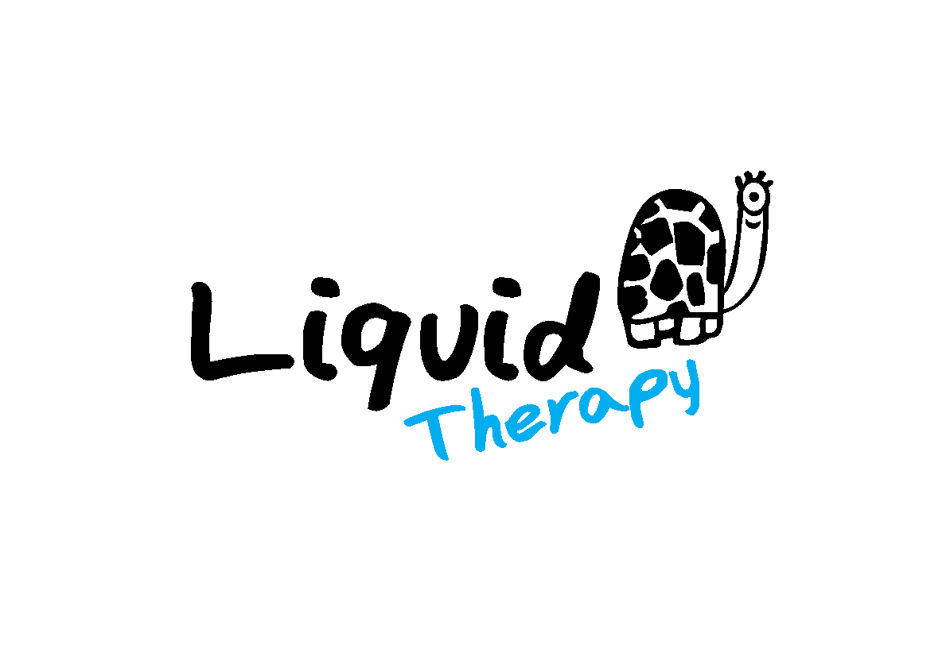

# Terms and Conditions

Our terms and conditions outline how we work with individuals, families and groups. Please read carefully as these aim to support the Liquid Therapy team to ensure that our sessions are appropriately resourced and safe, and provide the best experience for each participant. Don’t hesitate to get in touch with our team if you have any questions.

* **Cancellations:** If you need to cancel please let us know ASAP so we can accommodate others on our waiting list. If due to weather conditions Liquid Therapy has to cancel a session you will be given at least 24 hours notice.
* **Media:** Caregivers and group leaders must notify the Liquid Therapy team prior to the session beginning if they do NOT want the session captured on camera or film. Please read our “Media and Image Release Agreement” for guidance.
* **Medical**: Please bring any medical items you may need so that they are available if required during sessions, such as inhalers, epipens, etc.
* **At the Surf Centre**: Caregivers and group leaders are responsible for getting participants changed into wetsuits and supervising changing rooms on arrival at the Surf Centre.
* **At the Beach:** Caregivers and group leaders are responsible for participants for the duration of each session. Please note a responsible adult must remain on the beach and available during all sessions. Caregivers and group leaders should remain out of the water in the flagged zone unless otherwise agreed with the Liquid Therapy team.